3D Fabrication & Prototyping

Antti Männikkö

Jani Lehtovirta

Laura Rinne

2016

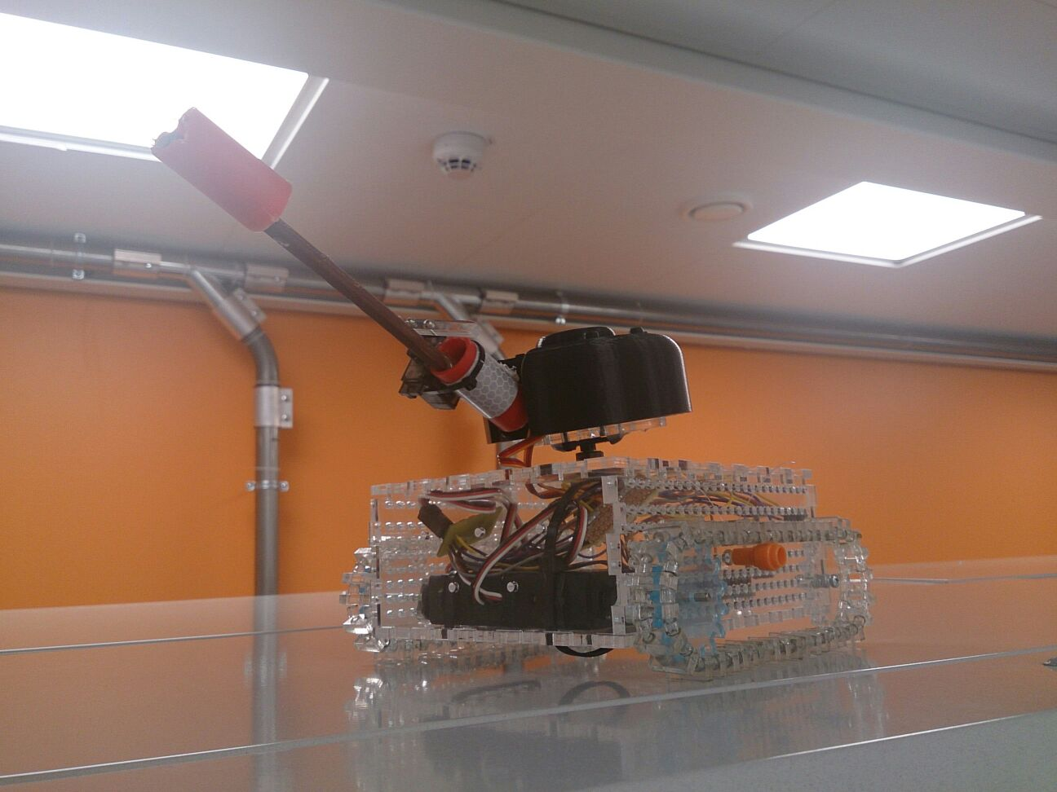

**INTRODUCTION**

We decided to make a small bluetooth-controllable tank, that could also shoot something from its cannon. Therefore it would be necessary to turn the turret of the tank to target something. We came across this idea by seeing something rather similar on Youtube (it didn’t have the shooting ability, though).

After many design ideas we decided to make a tank with straight edges (picture 2), so we can easily modify for example the tracks of the tank. We thought it would be best to make a lot of holes with different sizes on the sides of the tank so we have many options on where to place the motored wheel of the traces. At first we planned to make the sides of the tank a little bit oblique (picture 1), but we thought it would not be that practical.

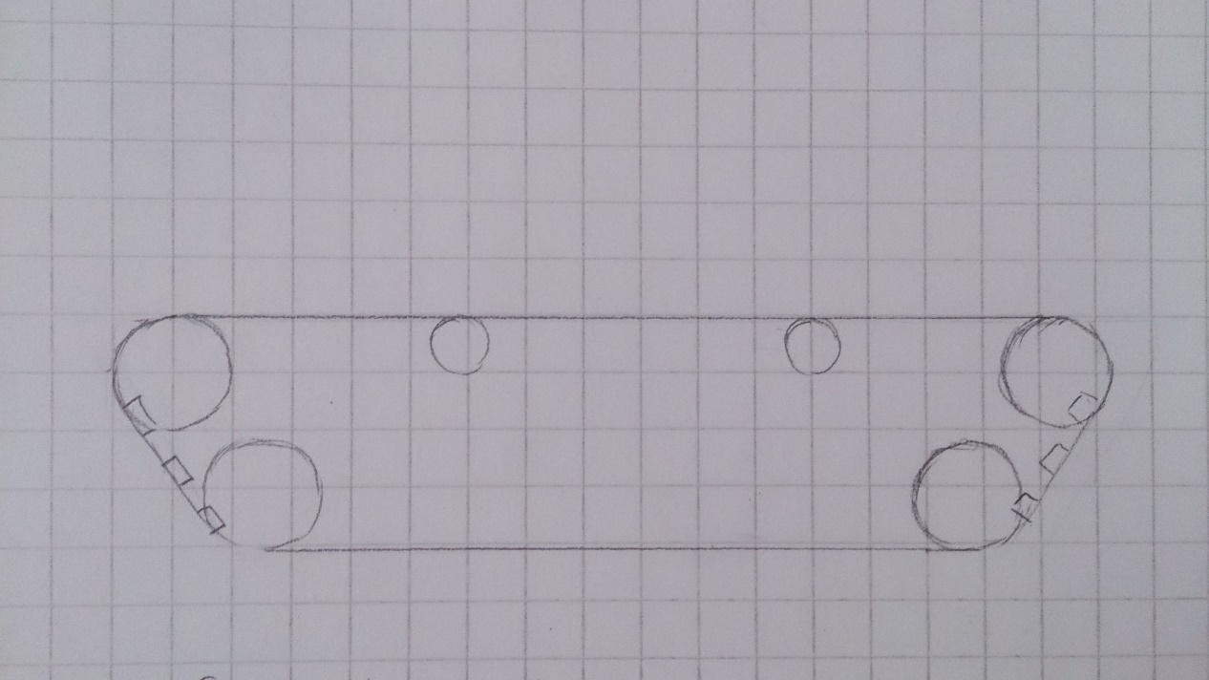

Picture 1: The first design of the shape of the tank, where the sides of the tank are oblique.

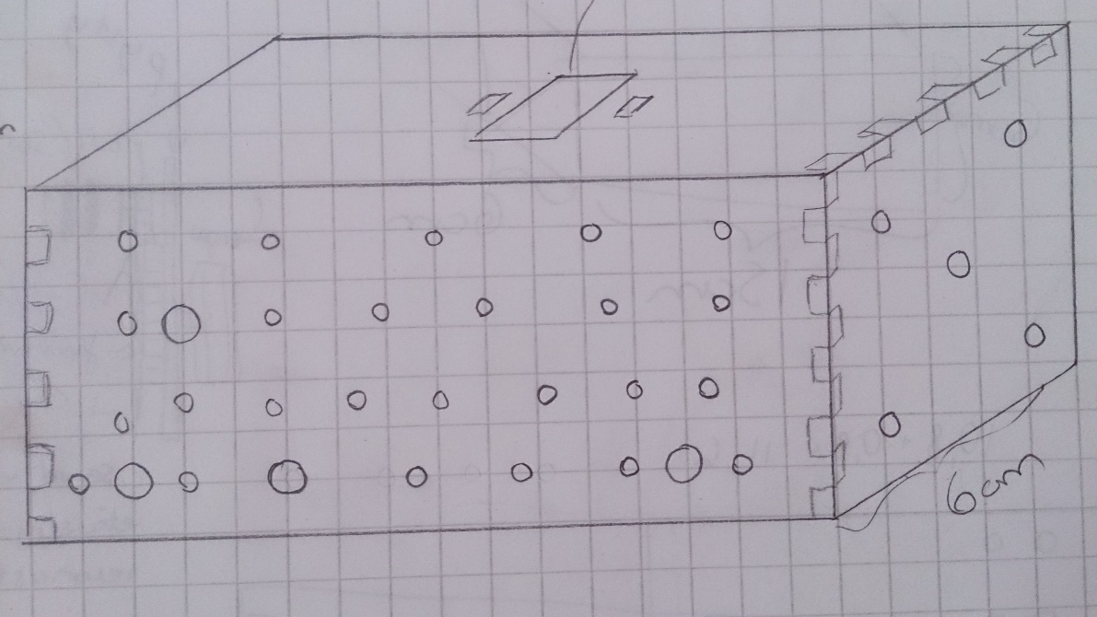

Picture 2: Sketch of the tank with straight edges.

Now we have the design planned for the base of the tank, but we still need design for turret, cannon and traces. We want to keep the turret looking simple and militarylike. In the picture 3 you can see the design we aim for.

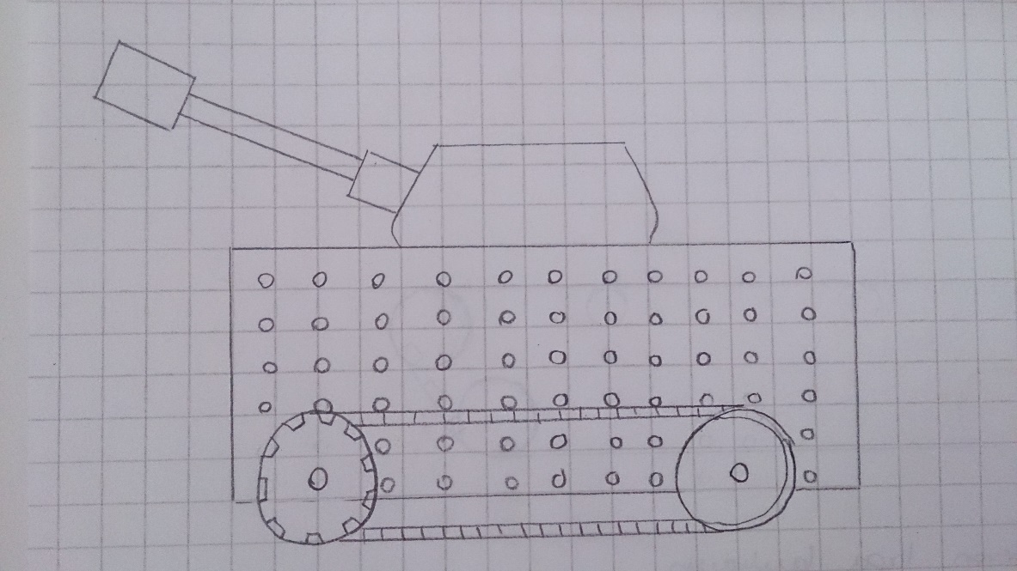

Picture 3: Sketch of the design we want to achieve.

**BASE OF THE TANK**

We start by making a box that hides the electronics and is the base of the tank. We download a Tabbed Box tool for Inkscape (<https://github.com/paulh-rnd/TabbedBoxMaker>) and save it in Inkscape > share > extensions. Then in Inkscape it can be found in the Extensions-menu in the Laser Tools -section. We decide to make a box that is 150mm * 116mm * 60mm so that all the components fit inside of it. Although we don’t laser-cut the whole box at first. We test different Kerf-values on small two panel pieces first. We test kerf-value zero first and it is way too loose as can be seen on picture 4. We want the box to stay together without glue.

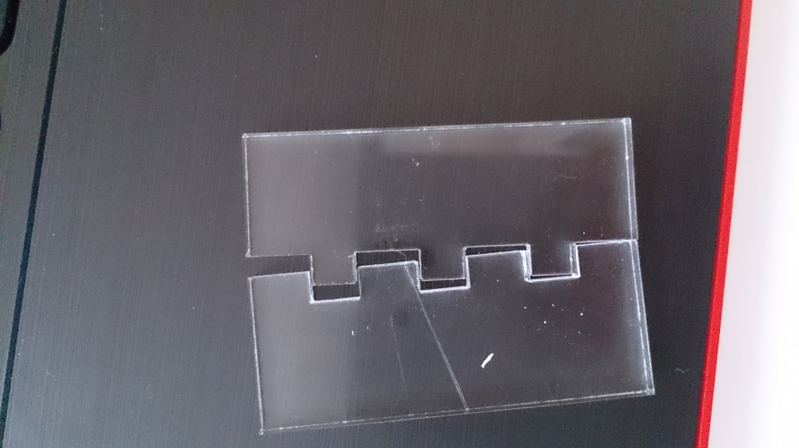

Picture 4: Test piece with kerf-value 0, visibly too loose for our tank.

We then do some googling and decide to try kerf-value 0,2, but it is way too tight. Pieces kind of fit together, but we’re afraid of breaking the ”teeth”. We try again with value 0,18 and then the pieces fit together just fine. Not too tight, but very stable as can be seen in picture 5.

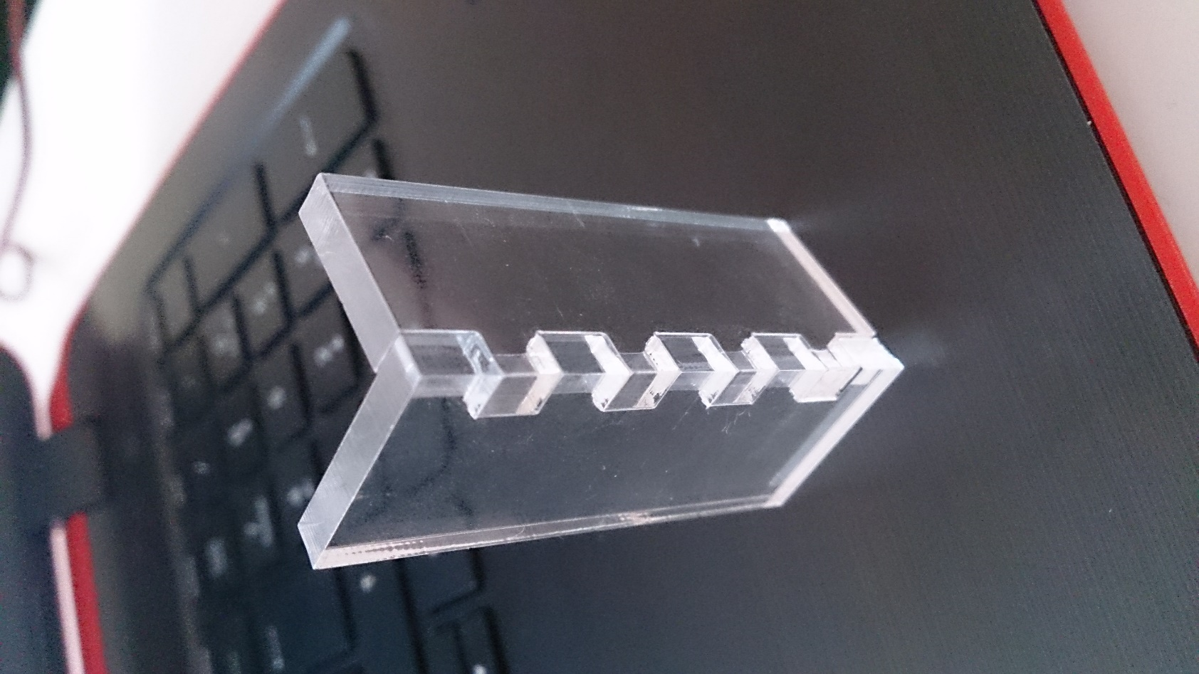

Picture 5: Kerf-value 0,18; panels are firmly attached to each other, but it’s not too tight.

Now that we have the values as we wanted, it was time to create the box using correct dimensions and values shown in the picture 6.

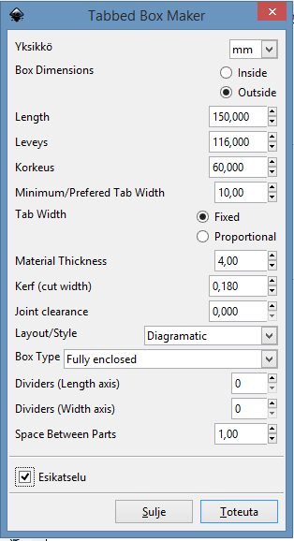

Picture 6: Tabbed Box Maker window with correct values for our tank base.

Now we have a blank box with wrong linewidht (it has to be 0,02mm for the lasercutter to regognize the cutting lines). We adjust the line width and start to draw the holes on the sides. On long sides (150mm*60mm) we decide to make a lot of holes with diameter of 3mm, so that the wheels can be connected to the motors via them with a right sized bar. There is 3mm between two holes, but one line of holes is only 1mm away from the edge, so that a small wheel can be used too (not connected to motors though). The long side design can be seen in picture 7. We need two of these parts for the whole tank.

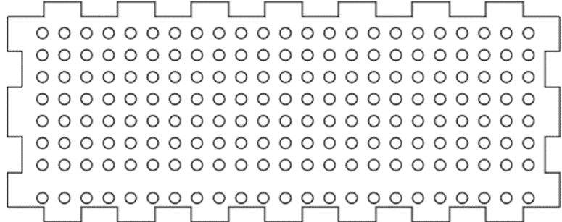

Picture 7: Long side pieces (150mm * 60mm) of the tank will be laser cutted to this shape.

Top piece of the tank needs to have a right sized hole for a small servo motor and its screws (one on both sides of the motor). This motor will be the one to turn the tank’s turret. Top piece’s design can be seen in the picture 8 below.

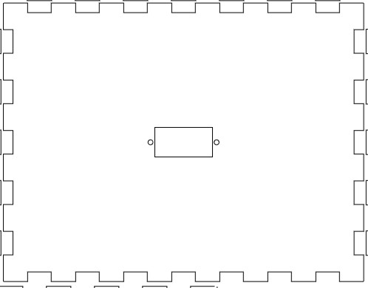

Picture 8: Design of the top piece of the tank’s base.

Bottom piece of the tank needs to have two rows of bigger round holes (5mm diameter) on each side for bigger servomotors to be attached to it with cable ties. It also needs one big hole (10mm diameter) in the middle because it might be necessary to put some of the wires through that. Picture 9 shows how the holes are organized on the board.

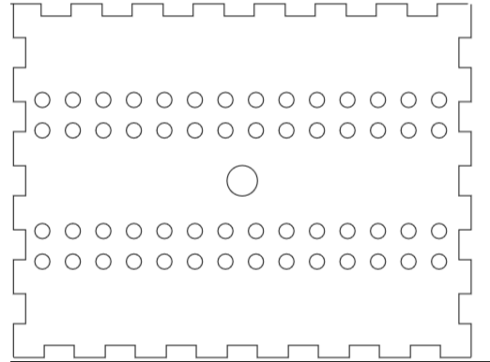

Picture 9: Bottom of tank’s base with holes with different sizes. Small ones (5mm diameter) are for servomotors’ cable ties and big one for other wires.

Now we decide what kind of holes the small end pieces need. There wasn’t anything we need to attach to those ends, so we just added 5 holes for decoration purposes. Diameter of those holes are 3mm.

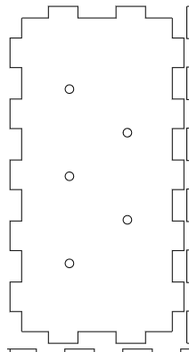

Picture 10: End piece of the tank base with decoration-holes.

Now we have the perfect box for our purpose, so first we cut it from cardboard to see if everything is ok. All the things seem to be fine, so we cut it from clear acrylic.

A big problem appears: the servos inside the box need a new piece of acrylic on top of its turning blade. Those pieces widened the servos so much (8mm) that they don’t fit inside the tank side by side. Therefore we have to add 10mm to the tanks width. Now it has to be 126mm. We also realize that the top piece needs a hole for turret’s wires (cannon adjustment servos’ wires). We could still use the same long side pieces as before, so we cut only the parts we need to, with the new features.

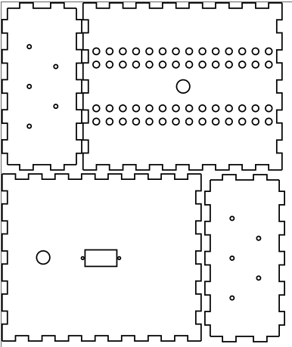

Picture 11: New bottom, top and end pieces for the base with new dimensions and an additional hole.

Cutting all the pieces at the same time from acrylic took about 6 minutes. The base turned out ok, and it gives us possibilities to modify the tracks by having enough wheelholes on the sides. Picture 12 shows how the base turned out. It seems a bit messy because of all the wires inside, but everything fits into it nicely. For the base of the tank we need 26cm * 37cm piece of acrylic.

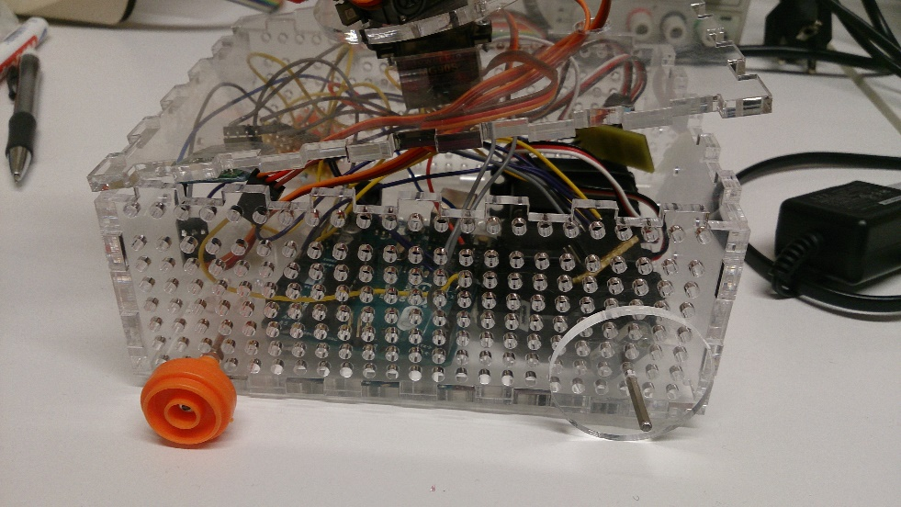

Picture 12: Tank base with servomotors and wires inside of it. Also wheels attached for testing the hole placement.

**BASE OF THE TURRET OF THE TANK**

At first we laser cut a circle (diameter 7cm) with holes for two servo motors. Therefore we need 70mm*70mm piece of clear acrylic. One motor spins the turret and the other one moves the cannon up and down. The spinning servomotor needs to be attached with screws and the lifting motor with a cable tie. Picture 13 shows how the holes are organized on the turret base piece.

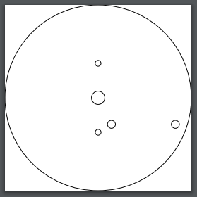

Picture 13: Cutting lines for the base of the turret of the tank. Big hole in the middle is for servomotor’s big screw and the small ones next to it are for smaller attaching screws. A little bit bigger holes are for the other servo’s cable ties.

**CANNON LAUNCHING AND LIFTING MECHANISM**

We need to attach a small piece of acrylid to cannon launcher servo and to the servo, that moves the cannon. The launcher needs to be longer that servo’s blade, so we need to screw a piece of acrylic to it, so that the cannon can launch the rubberband that is streched across it. Also the cannon moving servo needs to be attached to the cannon itself with a separate acrylic piece, because the servo’s blade is so small. Pieces can be cut from 20mm * 40mm piece of acrylic

**USED SERVOMOTORS**

**SM-S4303R**

For moving the tank we use 2 continuous servos (SM-S4303R), each on one side. It has three wires: white (PWM), red (VCC) and black (GND).

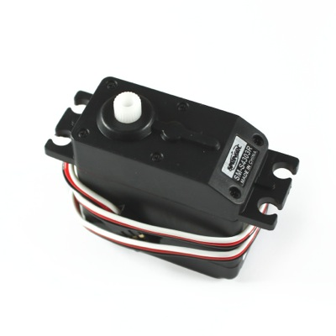

Picture 14: These SM-S4303R continuous servomotors are use for moving the tank. (https://oceancontrols.com.au/MOT-314.html)

**Tower Pro MG90S (Micro servo)**

Movements of the turret and the cannon are made by using small 180 $°$ servomotors. We need 3 of these servos. One to turn the turret, one to move the cannon and one to trigger the cannon. MG90S has three wires: orange (PWM), red (VCC) and brown (GND).

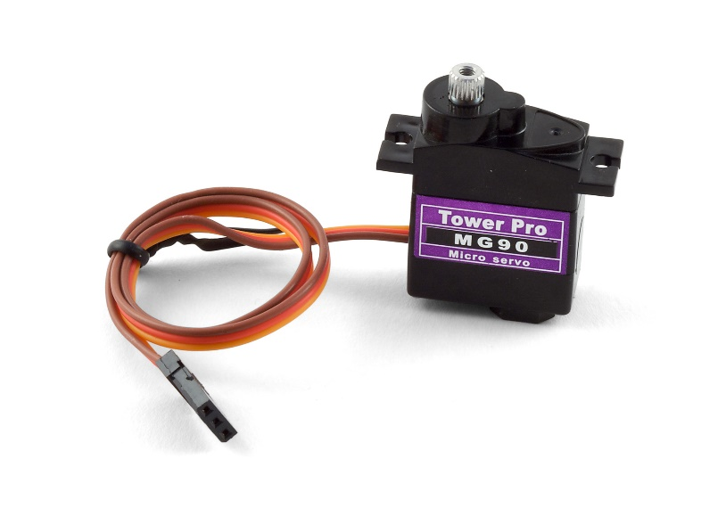

Picture 15: These Tower Pro MG90S micro servos we use for turning the turret and cannon and also launcing the cannon. (http://www.phidgets.com/products.php?product_id=3205_0)

**VOLTAGE REGULATION CIRCUIT**

We need a small one sided PCB with SMD components to regulate the battery voltage (7,4V) to 5V which is the voltage that our servos use. We need two ceramic capasitors (330μF), one regulator (LM7805), and 3*2 SMD pinheader. Regulator drops the voltage to 5V, two continuous servos are connected to the pinheader, and the capacitors are there to prevent voltage spikes. We need about 2mm * 35mm piece of circuitboard blank.

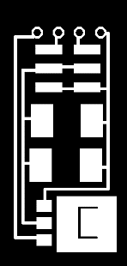

Picture 16: PNG-file of our PCB. On the left is voltage regulator, next two components in the middle are capacitors, 3*2 pads are for pinheader, and four holes on the right are for Vin, two PWM signals and GND.

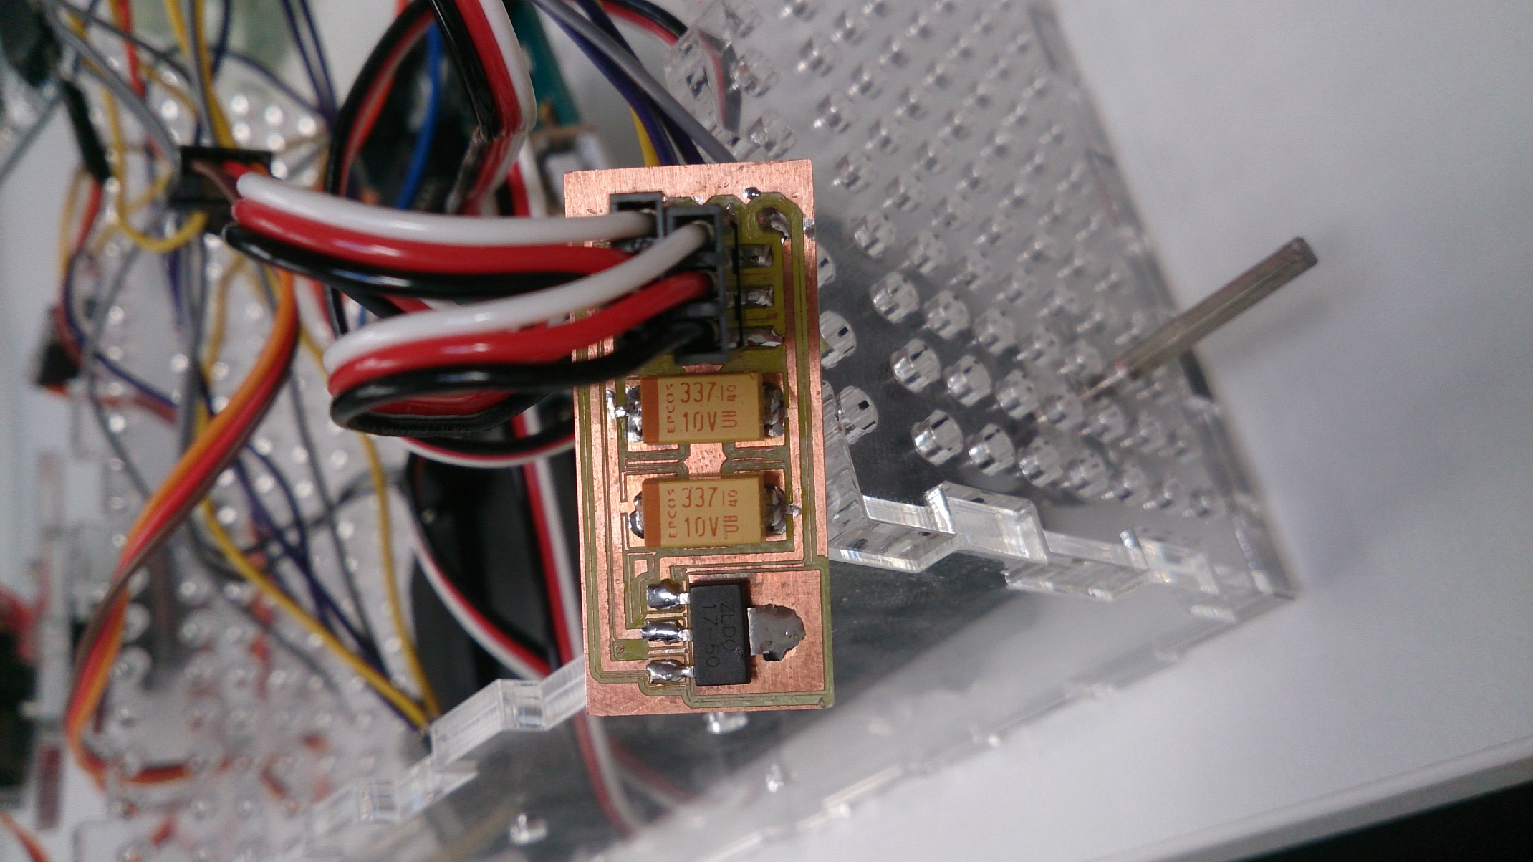

Picture 17: Finished PCB with attached components.

**ARDUINO UNO**

Arduino Uno is based on microcontroller Atmega328P. It has 14 digital output/input pins and 6 analog inputs. 6 of the digital inputs/outputs can be used as PWM outputs. It has 16 MHz quartz crystal and a USB connection (makes coding the board easy). It has the operating voltage of 5V, but input voltage can be 7-12V. It has a built-in regulator that drops the voltage to 5V. Our arduino Uno can be seen in picture 18.

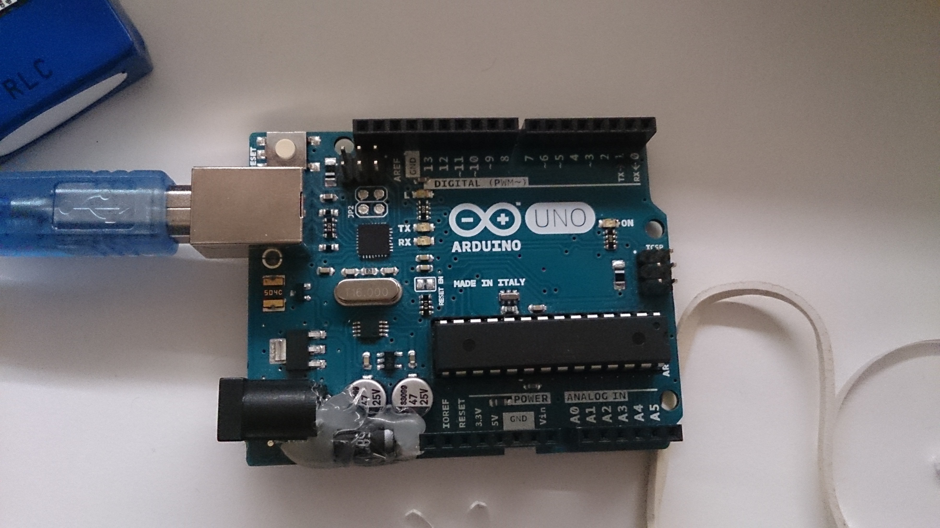

Picture 18: Arduino Uno board which we use for coding and controlling our tank.

**BLUETOOTH MODULE**

We use HC-06 bluetooth module for wireless communication between Arduino board and the tank. We downloaded Bluetooth RC Controller –app to Antti’s Android phone from Play store, to make it easy to control the tank remotely. The bluetooth module is attached to serial port (digital pins 0 and 1), 5V and GND. The bluetooth module we decided to use can be seen in picture 19.

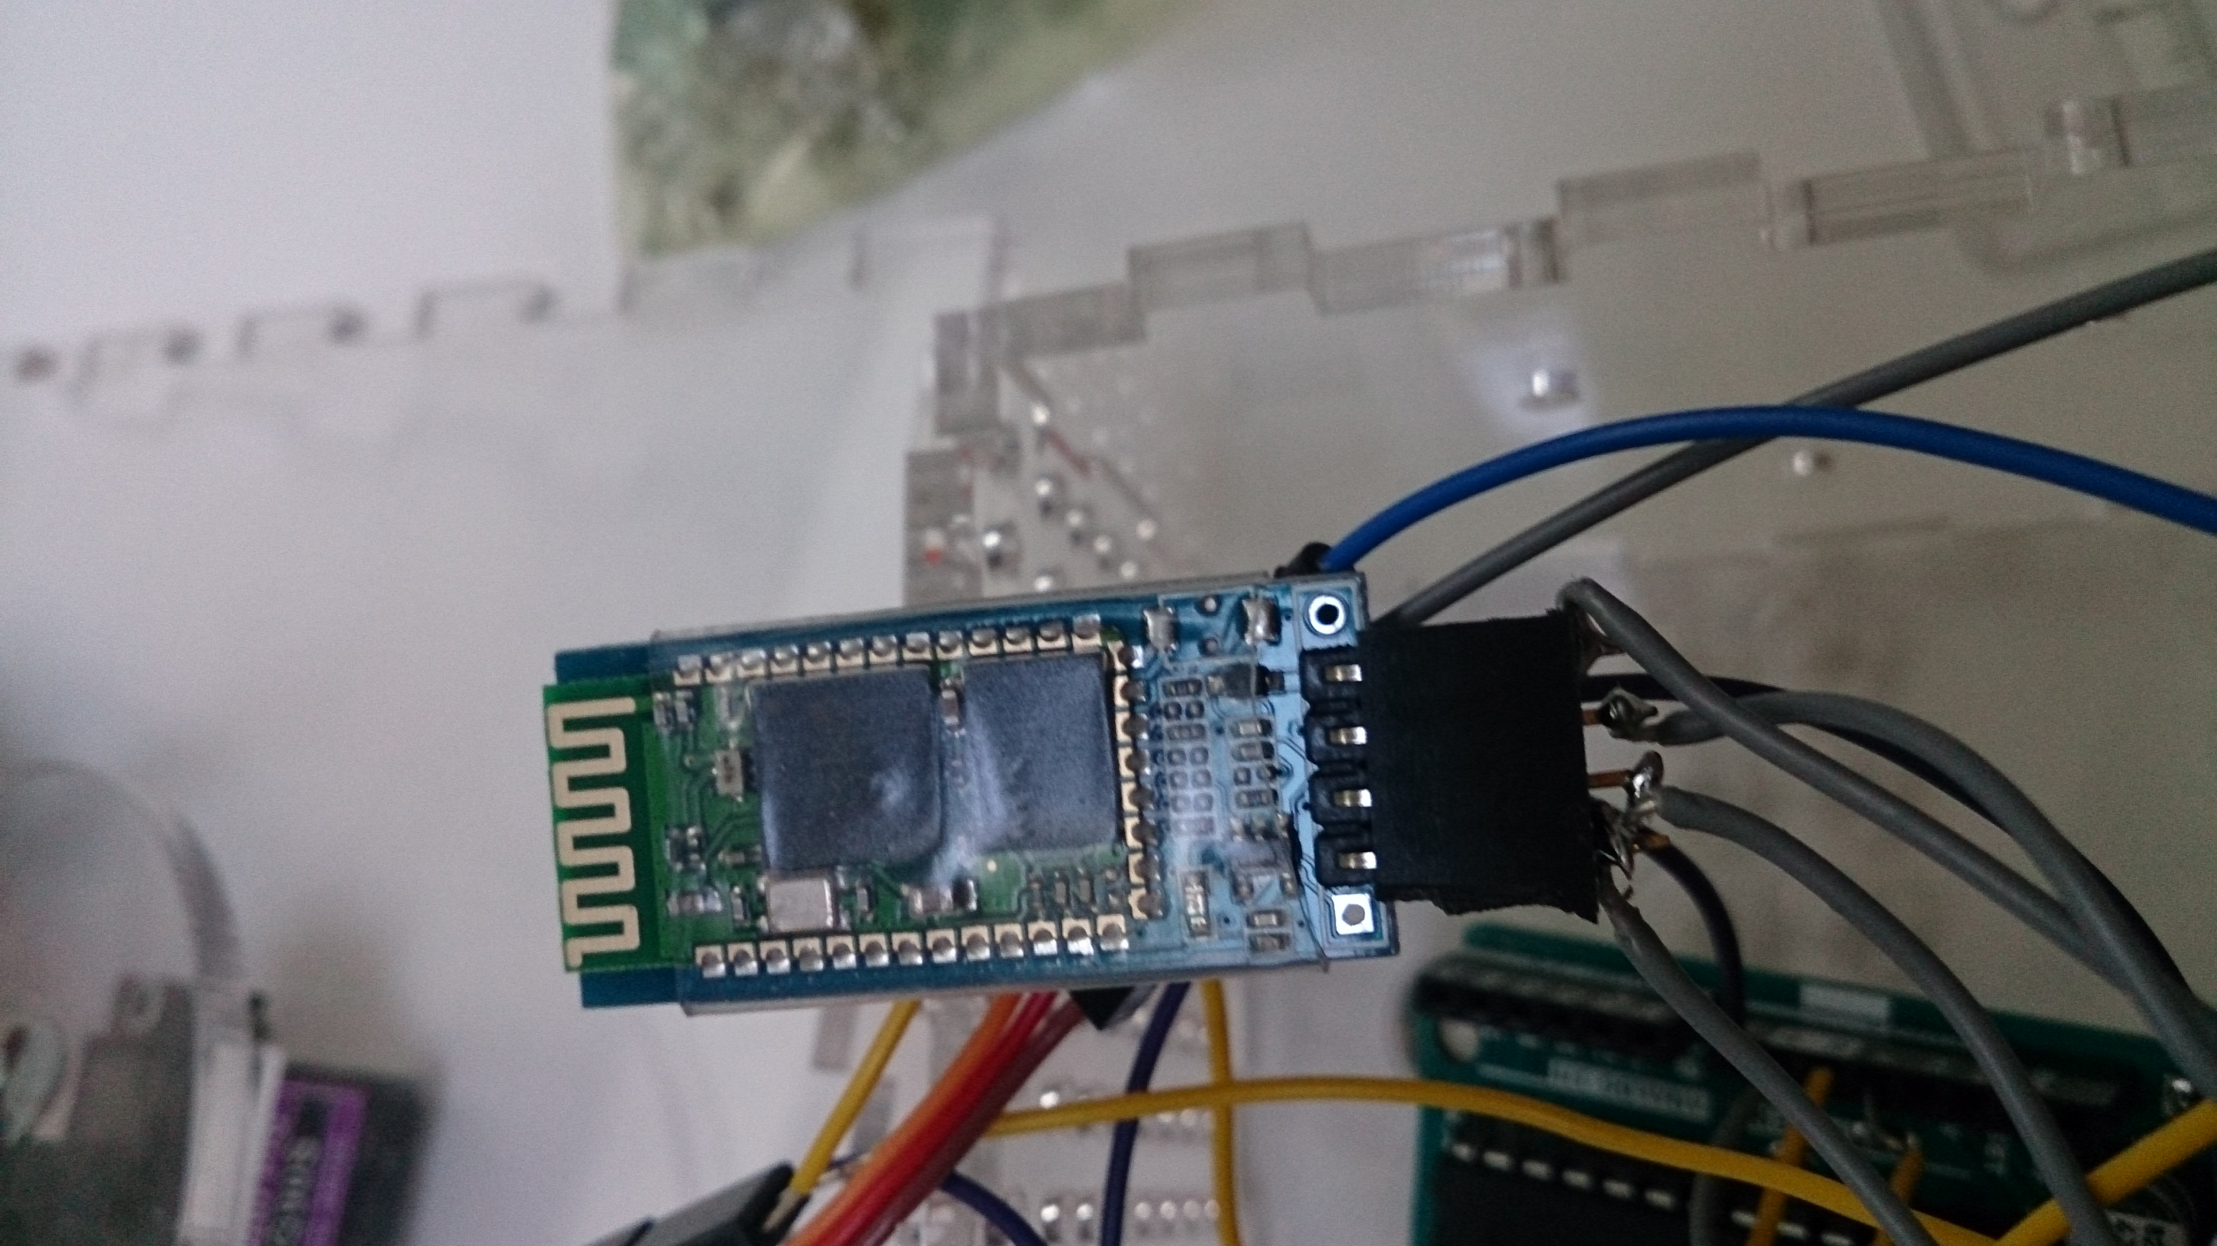

Picture 19: HC-06 Bluetooth module that we use for out tank.

**3D PRINTED TURRET OF THE TANK**

We design a turret that woud fit the base (7cm diameter) of the turret. We need to make sure that nothing comes to the cannon’s way when it’s moving, so we need to make a right sized gab for the cannon. The 3D model of the turret can be seen in picture 20. The diameter of the turret is 90mm and the gab for the cannon is 25mm wide. On the inside of the turret is a semicircle shaped pocket for the cannon servo. We decided to print the turret with Stratasys Fortus 380MC printer because it can use different support material. We used about 60g of PLA filament. The result can be seen in picture 21.

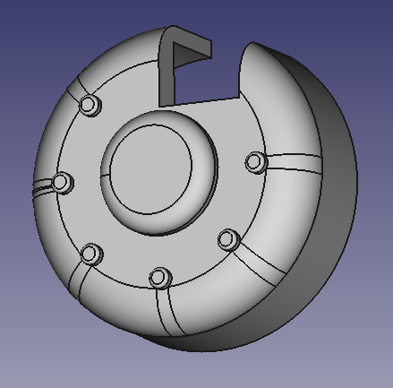

Picture 20: 3D model of the turret of the tank, that has a gab for the cannon.

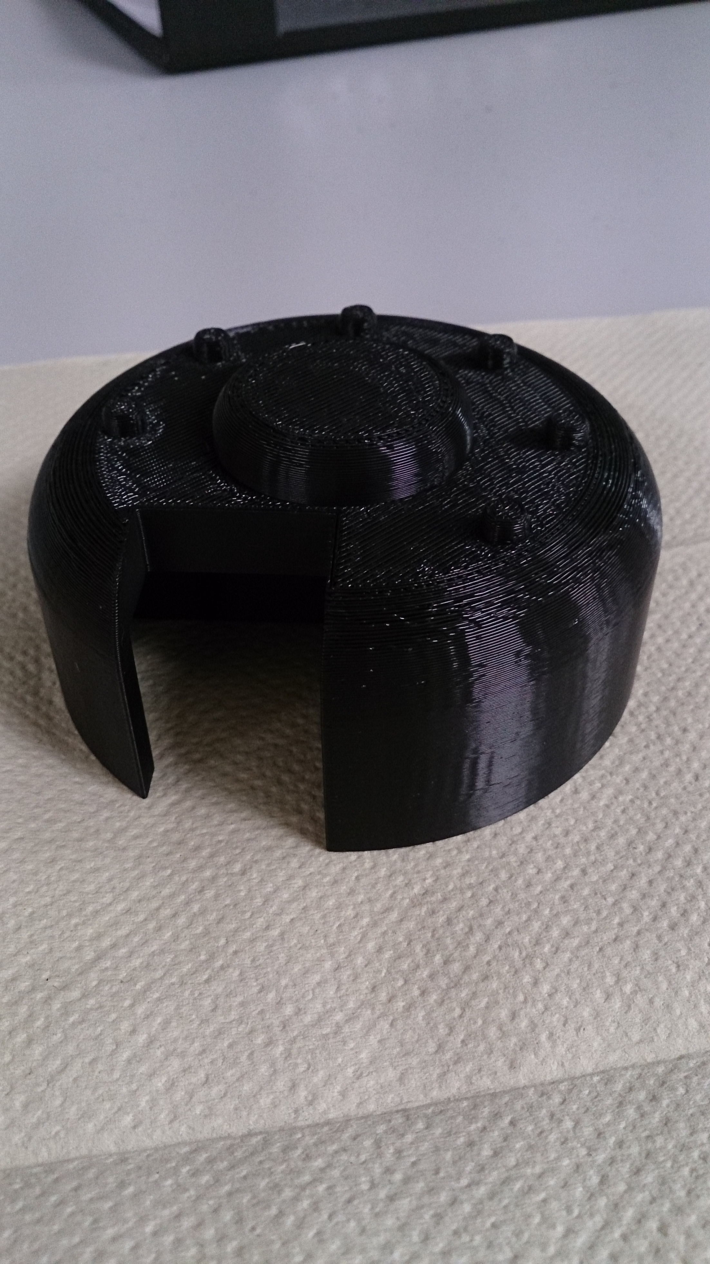

Picture 21: 3D printed turret for the tank, that was printed with Stratasys Fortus 380MC 3D printer.

**LASERCUTTED TRACKS**

We cut two different kinds of pieces from clear acrylic. Others are round (diameter 5mm, 84 pieces per track) with a 2mm hole in the middle and the rest (42 pieces per track) are 7mm*15mm with 2mm holes in both ends. For both tracks we need 15cm*21cm piece of acrylic. Picture 22 shows how the tracks are assembled on the tank.

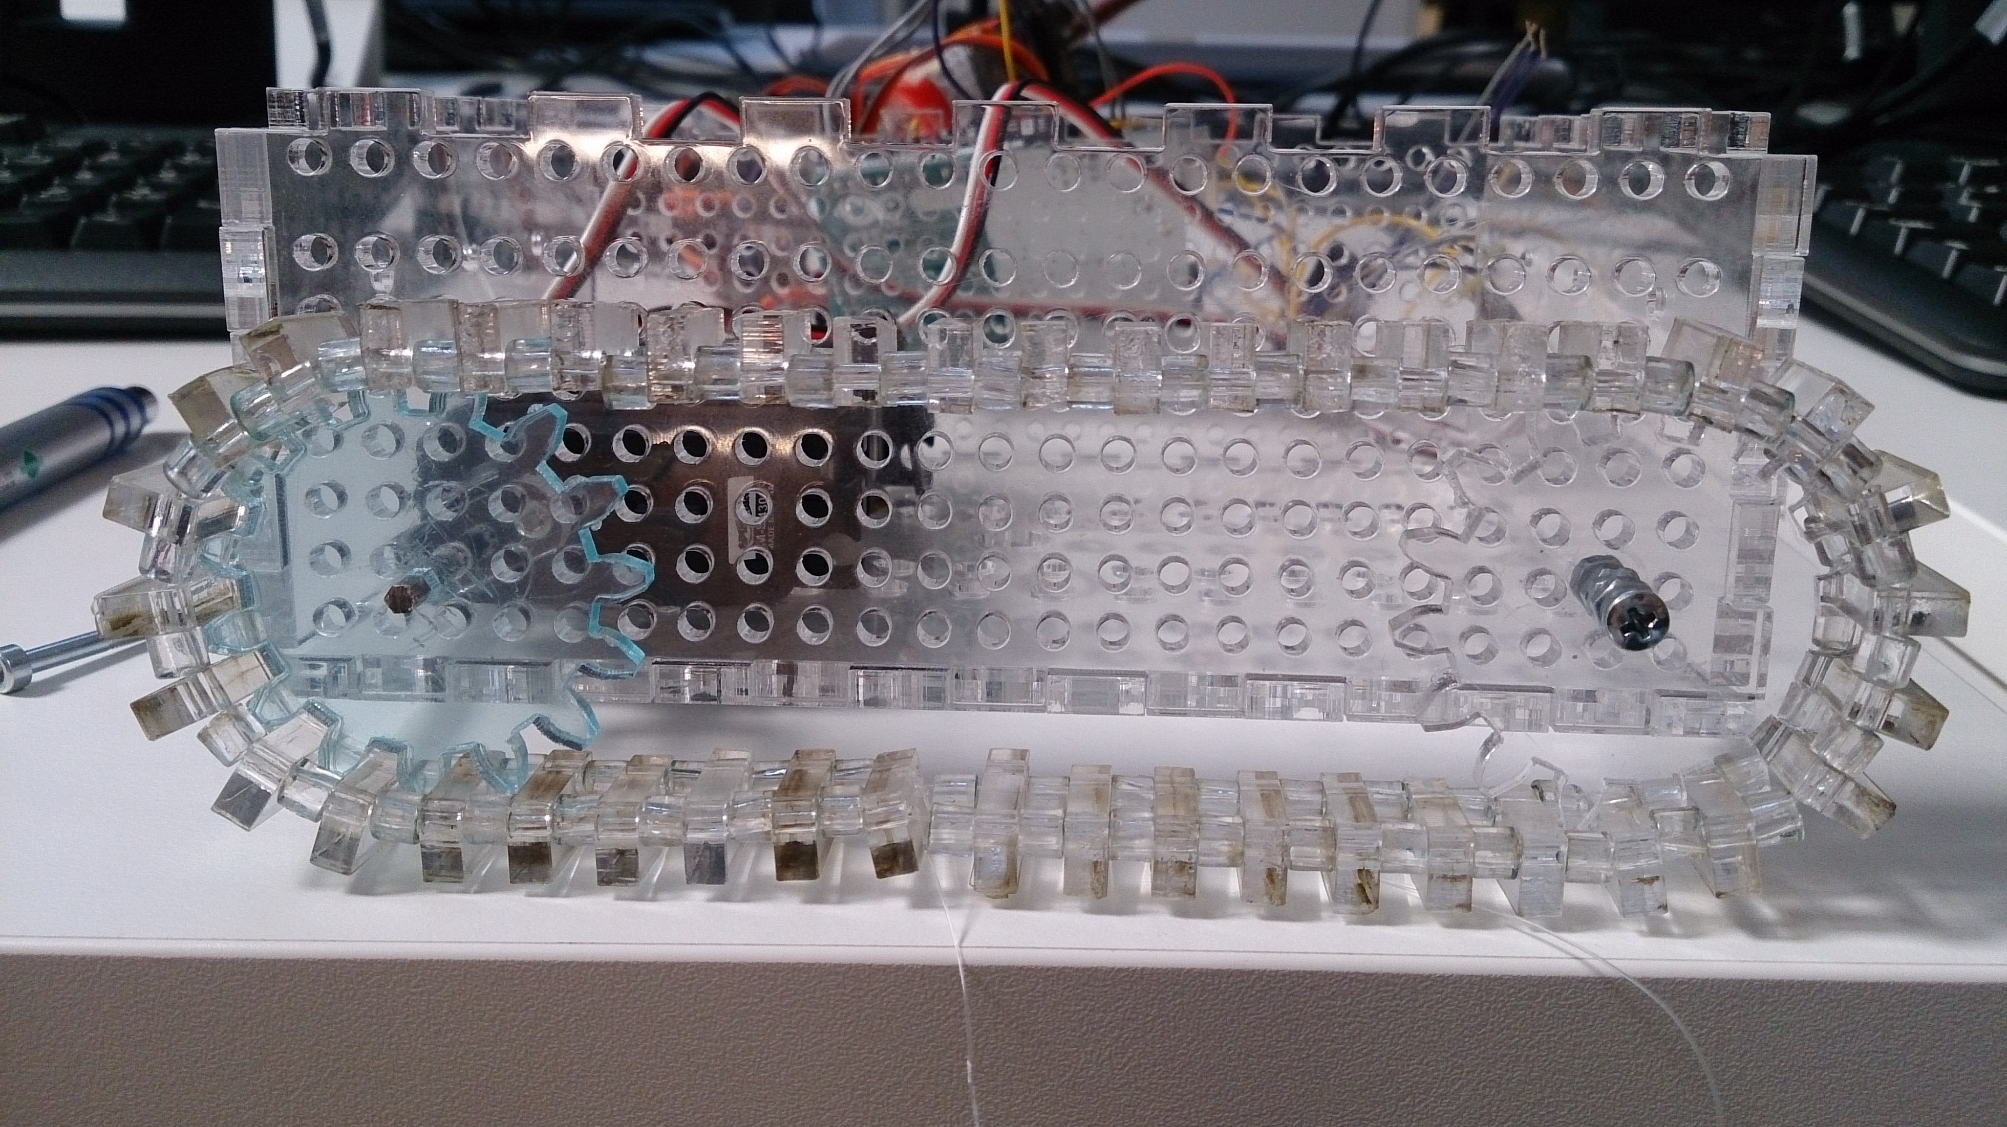

Picture 22: Assembled tracks of our tank, that are made of 126 pieces each. They are connected to each other with fishing line.

We use Inkscape’s Gear wheel tool (extensions > rendering > gear wheel) to make a fitting wheel for our track. Gab between holes in our track is the same as the thickness of the acrylic. Picture 22 shows how the gear wheels fit in to the track.

**ATTACHING GEARWHEELS TO SERVOSMOTORS**

Now we realize a problem with attaching the gear wheels (that turn the tracks and therefore make the whole thing move) to servomotors. We need to attach the axel of the wheel directly in to the middle part of the servo. We decide to make a small acrylic piece with three holes (middle one is a hexagon, other ones are round). Now we are able to attach the acrylic piece to servo’s blade with two small screws. The axel of the wheel is hexagonshaped bar, so it fits the hole in the middle perfectly. The gear wheel also has hexagonshaped hole in the middle.

**CODING**

Now we have everything inside of the tank and it is time to make the tank work with code. We used the code tank_3d_design.ino that can be found in Github. When everything is attached to its own place and the Arduino has been coded, we have a working tank! Now we use te battery power instead of USB –port and everything still works.

**NOTES**

To make your own tank you will also need a pencil, about 8cm of small tube and hot glue. To make the cannon, use hot glue to glue a 4cm piece of tube to both ends of the pencil and then glue the whole package to the cannon servo.

You will also need a bunch of cable ties and twosided tape (both big and small) to attach your servomotors to their place. The 3D printed turret of the tank can be either hot glued or taped to its base. In the picture 23 you can see how our tank turned out.

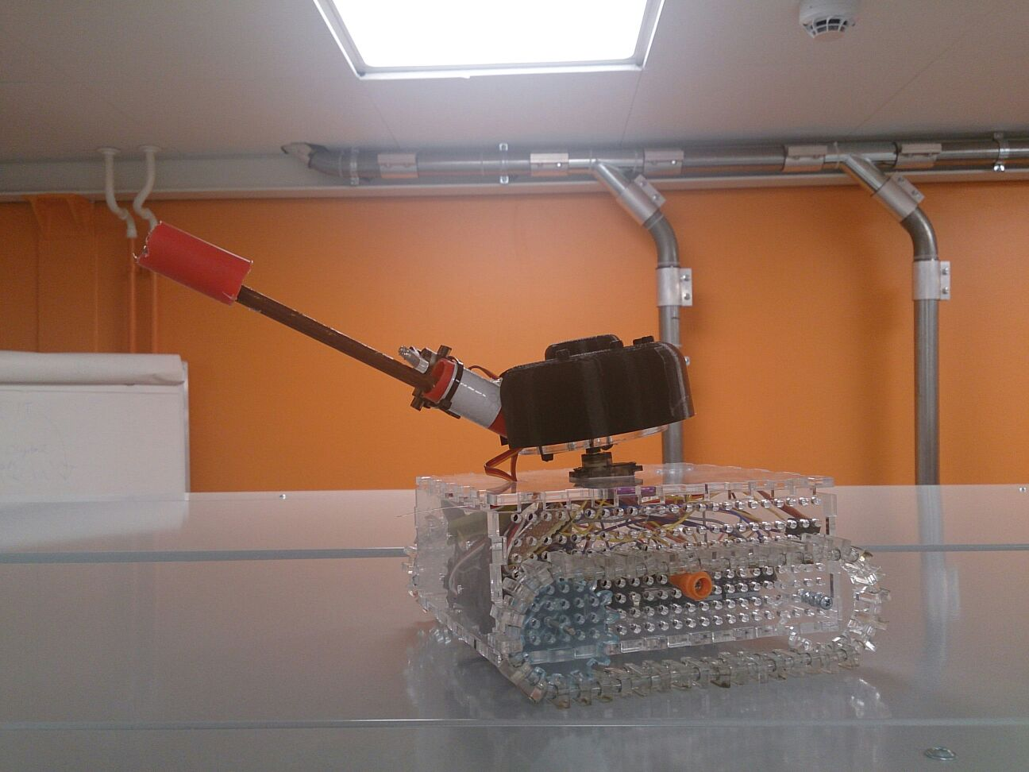

Picture 23: Finished tank, that has all the pieces in their places.